**UAS PRAKTIKUM KONSEP PEMPROGRAMAN**



**Oleh :**

**Nama : Rosi Arif Mulyadi**

**NRP : 3121522021**

**Prodi : D3 Teknik Informatika PENS PSDKU Sumenep**

**Kelas : 1 ITA D3 Sumenep**

**Dosen :**

**Lusiana Agustien M.Kom**

**POLITEKNIK ELEKTRONIKA NEGERI SURABAYA**

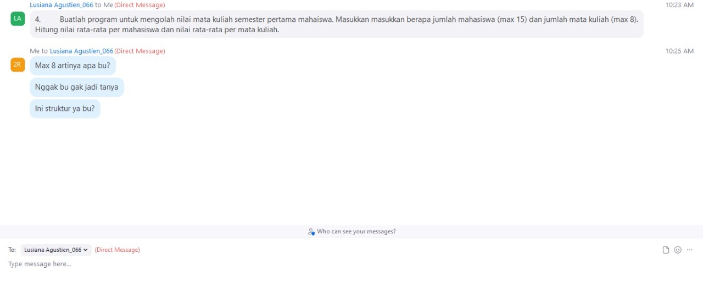

Soal !!!

1. Buatlah program untuk mengolah nilai mata kuliah semester pertama mahaiswa. Masukkan masukkan berapa jumlah mahasiswa (max 15) dan jumlah mata kuliah (max 8). Hitung nilai rata-rata per mahasiswa dan nilai rata-rata per mata kuliah.

Jawab :

Listing Program :

#include <stdio.h>

#include <stdlib.h>

#define MAKS 30

void cariRata(float[MAKS][15]);

void tampilkan(float[MAKS][15]);

main()

{

float nilai[MAKS][15] = {{1, 70, 70, 68},{2, 80, 80, 74},{3, 60, 90, 63},{4, 75, 85, 90}, {5, 76, 81, 88}, {6, 71, 82, 77},{7, 75, 85, 90}, {8, 78, 87, 88}, {9, 75, 80, 90}, {10, 78, 85, 91}, {11, 74, 83, 80}, {12, 75, 87, 87}, {13, 75, 89, 90}, {14, 75, 85, 90}, {15, 79, 88, 95}};

tampilkan(nilai);

cariRata(nilai);

}

void tampilkan(float data[MAKS][15])

{

int i,j,jumData = 8;

printf("Daftar Nilai:\n\n");

printf("---------------------------------------------\n");

printf("| %2s | %10s | %10s | %10s |\n","No","Konsep Pemprograman","Matematika 1","Desain Web","Matematika Diskrit","Praktikum Konsep Pemprograman","Logika & Algoritma","Dasar Sistem Informasi","Konsep Teknologi Informasi");

printf("---------------------------------------------\n");

for(i=0;i<jumData;i++)

printf("| %2d | %10.0f | %10.0f | %10.0f|\n",i+1,data[i][1],data[i][2],data[i][3], data[i][4], data[i][5], data[i][6], data[i][7], data[i][8]);

printf("---------------------------------------------\n");

}

void cariRata(float data[MAKS][15])

{

int i,j,jumData = 8;

float total = 0;

printf("\nNilai Rata-rata:\n\n");

printf("-------------------\n");

printf("| %2s | %12s\n","No","Rata-rata |");

printf("-------------------\n");

for(i=0;i<jumData;i++)

{

total = 0;

for(j=0;j<3;j++)

{

total = total + data[i][j];

}

printf("| %2d | %10.2f |\n",i+1,total/j);

}

printf("-------------------\n");

}

Output :

